
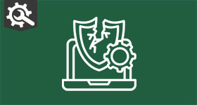 | 

📱💻 Does your child know more about technology than you do? You're not alone! 😅
Today's young people are growing up in a digital world and many are incredibly confident with technology. While that curiosity can lead to amazing opportunities, it can also lead them down the wrong path.
What starts as "just hacking a game" can quickly become something much more serious, including:
🔹 Data theft
🔹 Ransomware attacks
🔹 DDoS attacks
That's where Cyber Choices comes in. ✅
The Cyber Choices programme helps young people understand the difference between curiosity and cybercrime, empowering them to use their digital skills in a safe, legal, and positive way.
Because great cyber skills can build futures, not criminal records. 💙 Attend our families webinar on 28th July, register by clicking here
For other help and resources head to - Cyber Choices

